**task Description#1**  
● Zero-shot: Prompt AI to write a function that checks whether a given year is a leap year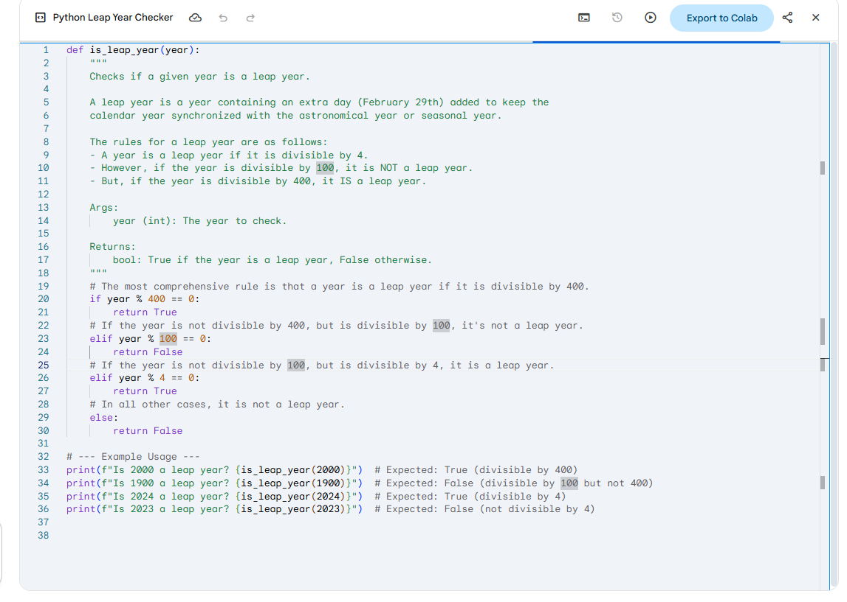

**Expected Output#1:**

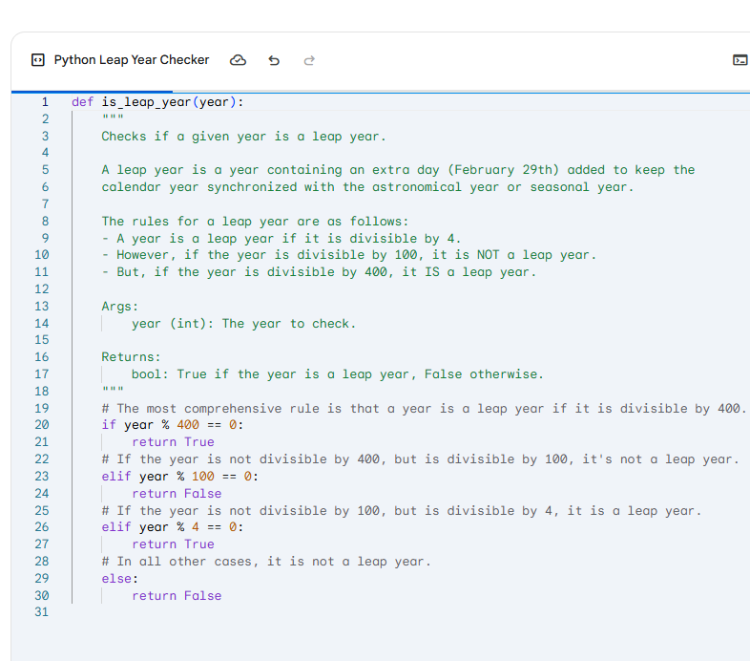

**Task Description#2:**

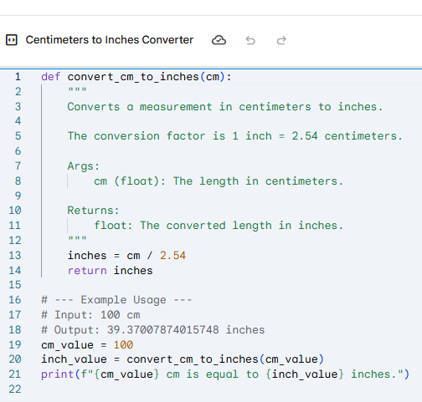

**Expected Output#2**

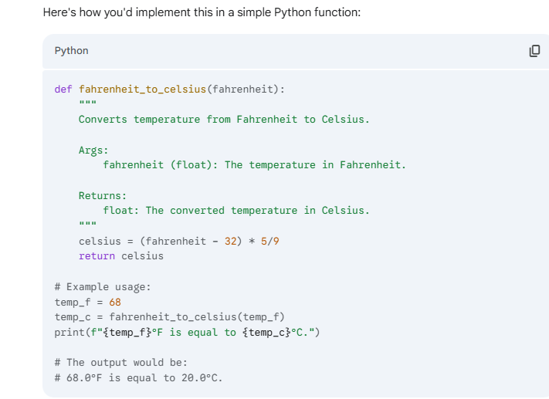

**Task Description#3:**

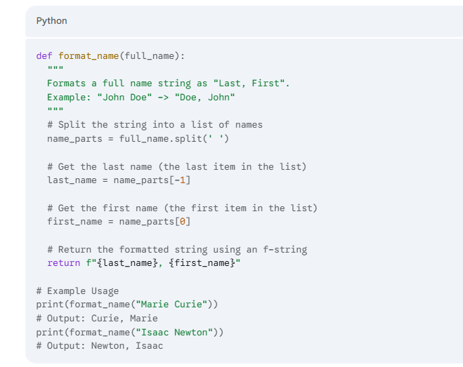

**Expected Output#3**

**This Python function handles the common case of a two-part name (First and Last). It splits the string by spaces, grabs the last part for the last name and the first part for the first name, and then uses a formatted string to return the result.**

**Task Description#4:**

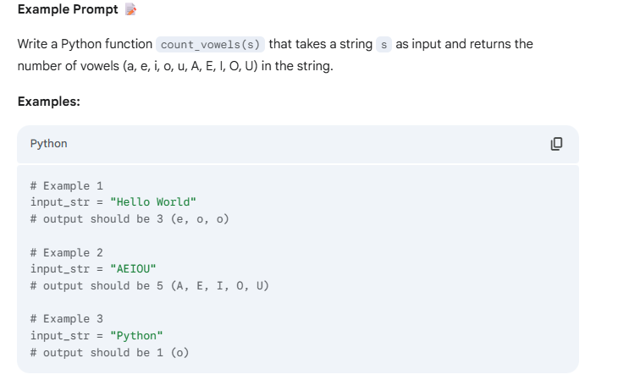

**Expected Output#4**

**A few-shot prompt provides a few examples of input-output pairs to guide the model. This helps it infer the specific behavior and format required.**

**Prompt:**

Write a Python function 'count_vowels(s)' that takes a string 's' and returns the number of vowels it contains.

**Task Description#5:**

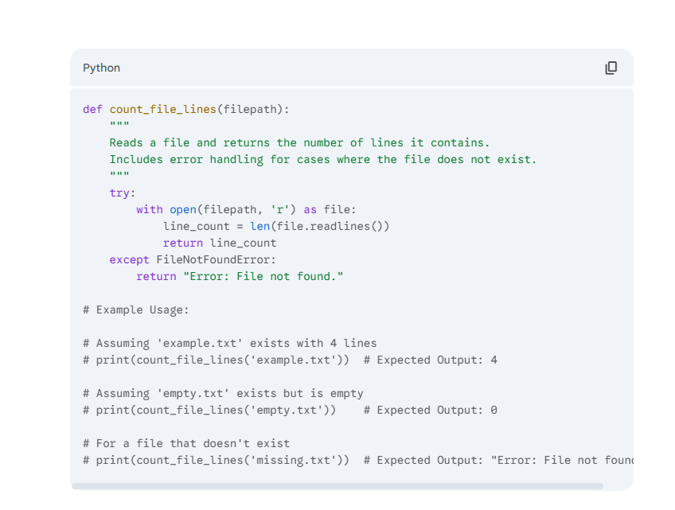

**Expected Output#5**

**Based on the prompt, the AI understands the need for a function that not only counts lines but also handles common file-system errors. The examples guide the model to use a try-except block, which is the standard Python practice for handling potential FileNotFoundError. The resulting function uses with open(...) to ensure the file is properly closed after reading, even if an error occurs. The readlines() method reads all lines from the file into a list, and len() then counts the number of elements in that list, which corresponds to the number of lines.**

**Note: Report should be submitted a word document for all tasks in a single document with  
prompts, comments & code explanation, and output and if required, screenshots**

